README

INTRODUCTION

The software team responsible for this product includes:

* Peter Gottleib
  + [gopeter1@umbc.edu](mailto:gopeter1@umbc.edu)
  + Project Logistics, Backend JavaScript Developer, Animator
* Constantin Koehler
  + [koehler1@umbc.edu](mailto:koehler1@umbc.edu)
  + MySQL, PHP, AJAX, JavaScript Database Backend Specialist
* Jacob Crouse
  + [jcrouse2@umbc.edu](mailto:jcrouse2@umbc.edu)
  + Backend JavaScript Mini-games Specialist
* Kwame Robertson
  + [kwame4@umbc.edu](mailto:kwame4@umbc.edu)
  + Web Design (HTML5/CSS3) Specialist

PROJECT LOCATION

The entire of the project is found in the proj2.zip file. Open proj2.html while connected to a web server and the game will be live.

VIDEO LINK:

PROJECT DESCRIPTION

Our project is a web replica of the original game Oregon Trail. Taking place in the 1860s, you are a traveling take an adventure across the U.S. on the Oregon Trail. Players will have to manage their wagon as they meet other travelers, ford rivers, and fight diseases throughout their journey. You can trade with other travelers and natives, fish for more food, raft across the Columbia River along with other features. Try and try again until you make it on the Oregon Ten with other top players.

WHAT WAS ADDED IF GIVEN OLD CODE?

Php code was given to make a basic database connection and issue a query. This was improved upon to make it work with AJAX.

Database Setup:

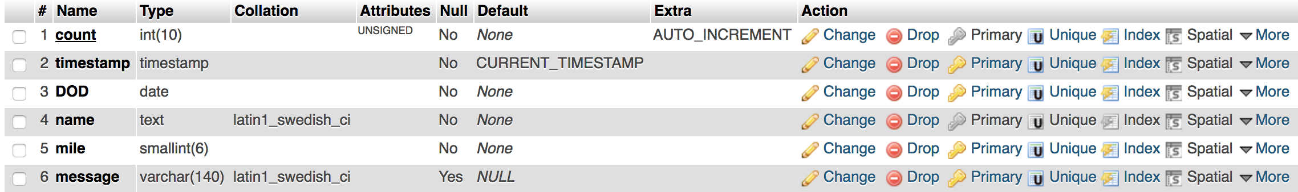

* Count: an auto incrementing field to avoid having to keep track of the numbers in our code.
* Timestamp: a field that is set to the current time when the insert command is received
* DOD: Date of death is based upon the date object stored in the game object. We used the date object to easily increment days
* Name: the name of the player
* Mile: The total distance traveled, this is relatively small so we made it a smallint
* Message: The epitaph, what it says on the tombstone, is a 140 character varchar. The length of a tweet seems appropriate.

DB Dump included in tombstones.sql.

7.

PHP was used to send database queries for tombstones.

AJAX was used in tandem with the PHP so we can check for tombstones asynchronously.

JQuery was used heavily in this project to alter the divs, set image visibility, change text, collision detection for mini games.

8.



Figure - Crossing Final River



Figure - Crashed the final



Figure - caught fish



Figure - fishing prompt

